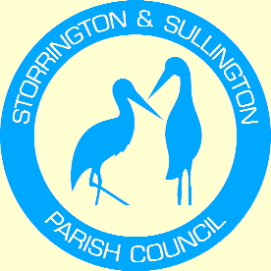
Storrington, Sullington and Washington
Neighbourhood Plan

WASHINGTON
PARISH COUNCIL

You are duly summoned to attend the Meeting to be held in The Chanctonbury Room, The Parish Hall, Thakeham Road, Storrington, on Tuesday 14th March 2017 commencing at 6.30 pm

A G E N D A

- Apologies for Absence

- To Receive and approve the minutes from the following meetings:
Steering Group Meeting – 11th October 2016.
- To review and consider documents produced by HDC – to be reviewed by independent examiner.
- SA/SEA Report
- Site Assessment Report
- Local Green Spaces Report
- Neighbourhood Plan Schedule of Changes

- To Consider Proposal from Washington Parish Council to create a special status for The Lanes of Heath Common within the Neighbourhood Plan.

- Any other Business.

Tracey Euesden (Mrs)
Clerk to Storrington & Sullington Parish Council 7th March 2017

