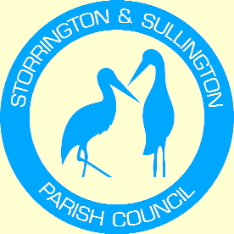
Storrington, Sullington and Washington
Neighbourhood Plan

WASHINGTON
PARISH COUNCIL

You are duly summoned to attend the Meeting to be held in The Chanctonbury Room, The Parish Hall, Thakeham Road, Storrington, on Tuesday 24th May 2016 commencing at 6.30 pm

A G E N D A

- Apologies for Absence

- To Receive and approve the minutes from the following meetings:
Steering Group Meeting – 19th January 2016
- Examiner’s Final Report and action to be taken – update following meeting with Horsham District Council.

- To discuss proposed amendments to Plan.

- DC/15/2788 – Land at Robell Way (Paula Rosa) Site. – To discuss and agree comments in response to amended Plans.

- Next Steps and any other business.

Tracey Euesden (Mrs)
Clerk to Storrington & Sullington Parish Council 13th May 2016

