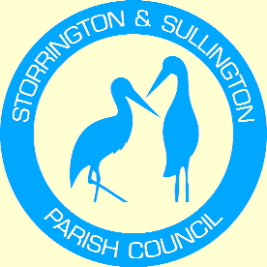
Storrington, Sullington and Washington
Neighbourhood Plan

WASHINGTON
PARISH COUNCIL

You are duly summoned to attend the Meeting to be held in The Chanctonbury Room, The Parish Hall, Thakeham Road, Storrington, on Tuesday 28th June 2016 commencing at 6.30 pm

A G E N D A

- Apologies for Absence

- To Receive and approve the minutes from the following meetings:
Steering Group Meeting – 24th May 2016
- To approve Revised Pre-Submission Plan and supporting documents for Public Consultation.

- To discuss promotional activity for Public Consultation.

Tracey Euesden (Mrs)
Clerk to Storrington & Sullington Parish Council 21st June 2016

