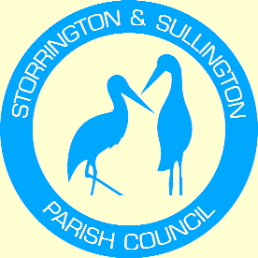
Storrington, Sullington and Washington
Neighbourhood Plan

WASHINGTON
PARISH COUNCIL

You are duly summoned to attend the Meeting to be held in The Chanctonbury Room, The Parish Hall, Thakeham Road, Storrington, on Tuesday, 21st January 2014 commencing at 7.00. pm

A G E N D A

- Apologies for Absence

- To Receive and approve the minutes from the following meetings:
  - Steering Group Meeting – 17th December, 2013

- Review of Progress to date.

- Feedback from Focus Group Meetings.

- To agree amendment to Terms of Reference to allow matters of a minor or non-financial nature to be delegated – to be signed by the Chairman.

- To review draft letters to local and national Stakeholders.

- Timetable of activities and to consider whether to hold a Planning Policy Workshop as part of the consultation exercises.

- Finance – To review expenditure allocation following HDC’s decision re provision of grants.

- Any other Business.

Tracey Euesden (Mrs)
Clerk to Storrington & Sullington Parish Council 13.01.2014

