STORRINGTON & SULLINGTON  PARISH COUNCIL  The Parish Hall, Thakeham Road, Storrington,  West Sussex, RH20 3PP  01903 746547  www.storrington-pc.gov.uk  Clerk: Rebecca Luckin (CiLCA)  Clerk@storrington-pc.gov.uk | 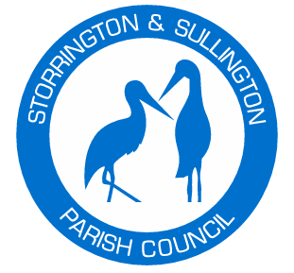

Dear Councillors- You are duly summoned to a
Planning and Development Meeting
of Storrington and Sullington Parish Council
in the Chanctonbury Room, Parish Hall, Thakeham Road, Storrington, RH20 3PP
5:30 pm Wednesday 15th October 2025
A Continuation of the Planning and Development Meeting dated 8th October 2025

Members of the public are welcome to attend this meeting and speak for a maximum of two minutes about an item on the agenda for this meeting during the Public Session at the discretion of the Chair. Please note that this is a meeting held in public, not a public meeting.

Mrs Katie Piper Clerk to the Council.
AGENDA

- Planning Applications awaiting Comment:
DC/25/1424 - Hareswith House West Chiltington Road Storrington, Extension of existing outbuilding.
DC/25/1390 - 41 Windmill Copse Storrington, Erection of a two-storey side extension to create 2-bedroom end terrace dwellinghouse.
DC/25/1329 - Priory Field Barn Monastery Lane Storrington, Change of use of volunteers agricultural storage barn to 1 no. residential unit.
DC/25/1551 - 30 Hawthorn Way Storrington, Erection of a single storey rear extensions to house and garage. Conversion of garage to living accommodation, replacement of roof and associated alterations.

Following the Local Audit and Accountability Act 2014, and with regard to regulations on Access to Local Government Meetings, members of the public are advised that they have a right to film and/or record the meetings of Storrington and Sullington Parish Council. Members of the public are also advised that by attending a meeting or video conference of the Council, they give their consent to being filmed and/or recorded by other members of the public, if such activity is taking place. Any equipment plugged into the main electrical power supply must be PAT tested.

