

Storrington and Sullington

Warden Monthly Report

January 2026



ASB (Anti-social behaviour)/Referrals
Police Report:
- Retrospective Police report not completed as Abandoned van on Water Lane recovered by insurance company as reported stolen. Wardens emailed by resident.
- Van reported to Sussex Police for having no MOT, whilst being parked on the street.
Intelligence report:
- Sent directly to PCSO with details of who allegedly is graffitiing car park walls.
- Sent directly to PCSO with drug dealing activities.
ASB :
- None to report.
Verbal Warning:
- None given.
Signposting:
- Resident to report parking issue to WSCC
- Resident to report dog attack to Police
- Resident signposted to family support
- Resident signposted to DVLA regarding untaxed van outside property
- Resident signposted to report incidents to social housing provider and Sussex Police.
- Resident signposted to HDC due to car accident and collection of dead deer
- Resident signposted to WSCC Highways regarding parking in Spierbridge Road
Safeguarding:
- None reported.

Parking/vehicles
Operation Crackdown reports: (Joint initiative with Sussex Safer Roads Partnership and Sussex Police to report anti-social driving.)
DVLA Reports:
- Untaxed Van reported to UKGOV/DVLA after resident reported to us that van had been parked in the same place for over a year (on the street).
Yellow Parking alerts:
- None issued.
Drivers spoken to for parking issues:
- 12 x vehicles parked on double yellow kerb stripes in North Street.
- 1 x vehicle parked in High Street loading bay.

Fly tipping/littering/graffiti.
Drug litter removed and reported to WSCC (West Sussex County Council):
- None to report.
Litter:
- Cleared litter from bench on Mill Pond
Fly tipping:
- None to report.
Graffiti:
- Graffiti at Place Villerest reported. Update: cleaned off
- Graffiti found on wall at Waitrose carpark, reported to HDC as it is their carpark. Update – cleaned off
- Graffiti reported to bus shelter company to clean.
- Cleaned two green telephone boxes of graffiti.
Flyposting:
- None to report.

Community engagement/events/meetings
PCSO (Police Community Support Officer):
- Request made for a matrix drop in suspected drug dealing areas.
- Meeting with PCSO, spoke about graffiti and drug issues.
Mother and Toddler Group:
- Visited the group to introduce Dave to them all. Good to see a few new faces, which is good as keeps the group going.
Village Market:
- Visited the market, it reduces the number of stalls for January. But all the stalls that were there were busy with the regulars.
Alzheimer’s Society.
- Email sent to local agent, to see if they knew anything about a post from the Mail about getting your care paid for without selling your house. The conclusion was that further investigation is required before applying on-line.
Agile training:
- Both wardens had training on agile, which is an internal reporting tool.
ORLO Training:
- ORLO training for social media attended by Dave at Albery House.
Storrington Library:
- Meeting with Managers to discuss new projects for 2026. They asked if we would get involved in joint activities.
Local Business Check in:
- Dropped off new posters for upcoming events
- Spoke to some of the retailers and checked there were no issues.
Stork Day Prep Meeting:
- Meeting attended to discuss preparations for upcoming Stork Day. Traffic management meeting scheduled for next week

Patrols (foot/visible/car)
Kithurst and Chantry:
- Checked on both sites, no issues.

Young People:
Youth engagement:
- Kids spoken to regarding inset day, and future travel to Rock Road.
- Child spoke to us at the stay and play, child informed us of Autistic diagnosis. Parent later on said that she didn’t want anyone to know about the diagnosis and was surprised that we were the only ones that she had told.
- Spoke to some youths at the leisure centre that came up to us as they hadn’t seen us for a while. They told us about their weight training and rugby and asked us if we wanted to come up and weight train with them one day.
- Spoke to some youths at the memorial pond, they spoke about what was going on in the village and gave me some workable information.
- Spoke to youth about weight training and they said we should come up and train with them.
- Spoke to kids at Mill Pond regarding clubs etc.
- Spoke to Rock Road student outside Costa, about youth activities.
SEND (special educational Needs & Disabilities) Stay and Play events:
- First of the new term, good turnout, with some new faces. Changed the layout of some of the activities and next week the new racetrack will be available to use. We received the new racetrack, funded by the Rotary club.
- This week’s event we had the new racetrack which the children absolutely loved, good turnout and thanks to early help family support for turning up.
- High numbers attending for the last event of the month.
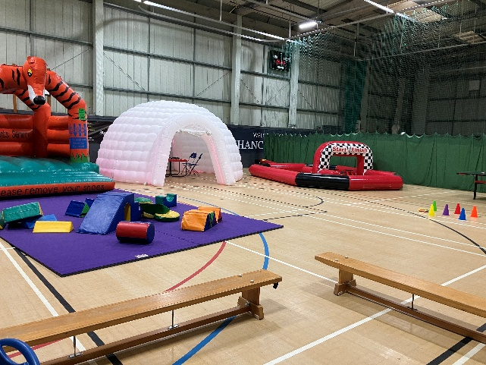

Dungeons and Dragons:
- Our events for this month had a good turnout from the regulars and a few new faces. We are going to try a different approach to the sessions to make them more interesting for the D&D’s, by setting up small groups so they can run their own campaigns.
School contact/collaboration:
- Email with posters of upcoming events sent to reception and Senco.
- We visited Rock Road several times at lunchtime to visit to the pupils. This gives us an opportunity to talk to the pupils and for them to engage with us.
- Had a meeting with FOSS (friends of Storrington school) Chairperson to discuss more walking busses to school, litter pick and Duck race.
- Storrington school Senco came to our stay and play group. We discussed further joint ventures.
Family Support Meeting:
- Had a meeting with WSCC family support team to finalise our joint Send play day in the easter holidays at Chanctonbury leisure centre. All looking good and full steam ahead

Elderly and vulnerable residents:
Vulnerable residents’ welfare visits and phone checks:
- Spoke to resident seen struggling to walk – all ok with only a short journey.
- Called 8 x residents to arrange pickups for cuppa and a chat.
- Resident stopped me to ask for help with her son. We have arranged to visit her and talk with the son. Contacted Resident to confirm appointment. Resident visited by both Wardens. Spoke about issues relating to adult son living there and his needs. Glebe surgery contacted to find out about any social prescribing available. Social services to be contacted if escalated further.
- Received message to contact resident who is feeling isolated and lonely. List of community events to be compiled and dropped off in person.
- Delivered “no cold calling window poster” to resident that will hand them out to vulnerable residents in her community.
- Sent details of relevant agencies to resident to help resolve her issue of care. Will check back in a week.
Community Café:
- Library event had a low attendance due to snow and icy conditions. But help and advice was given to residents that attended.
- Hanover event amalgamated with First Aid CPR and Defib training.

Cuppa and a Chat:
- Good turnout despite the weather. Really good to see that the group were concerned about one of the usuals, as they had heard some information that they were not happy about. Welfare chat given and no worries as everything in hand by their family.
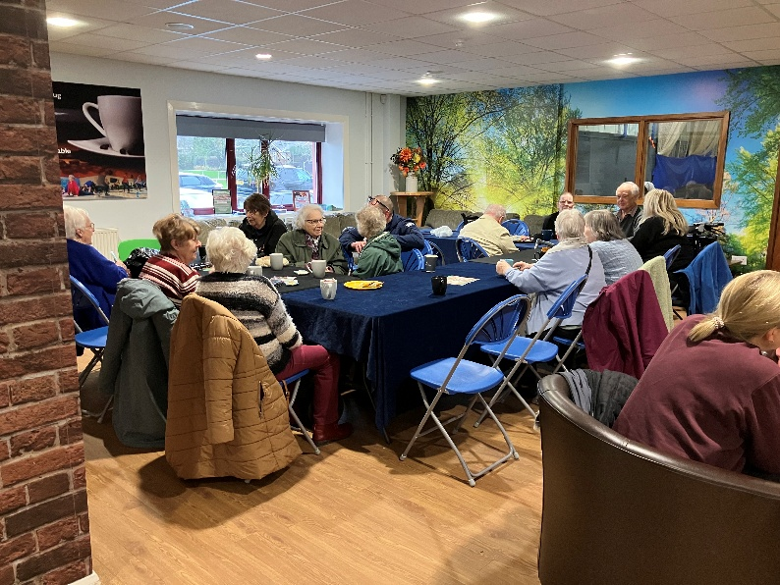

Hanover Walk Bingo Club:
- Have run several Bingo sessions at Hanover always a good turnout. It is good to see the residents enjoying themselves and getting out even though wet, cold and icy and enjoyed by all.
Chapel 5 Loaves Café:

St. Mary’s Church Café:
- Visited the café to talk to Wardens and reverend about our funday in August and what their stall would be for the event.
Journey group:
- Session at The Hub to begin 2026. Low showing but a positive experience. Gaining more numbers spoken about. More leaflet drops in the wider area a possible way, with the help of WSCC Early Help/Family support, plus direct contact from the Wardens.

Parish specific/other
Hazards and Risks:
- Bus shelter inspected and photos sent to clerk. Bus shelter has been taped off due to damage.
- Damaged path by Mill Pond reported to Properties dept. HDC along with pictures.
- Broken fence on Mill Pond reported to HDC for repair
- Environment Agency contacted regarding an overflowing sewage drain along river walk causing potential damage to the river during the recent rains.
- Three hazards in Library car park reported to Properties Dept HDC
Parish Polling Stations:
- Patrolled both Polling sites for Parish councillor elections
Social media/press
- 1 x Sussex Local monthly article.
- 1 x 3 Heralds monthly article.
- 12 x Facebook posts.

Breakdown of Time Spent on Parish Priorities

Tasks and priorities | Percentage of time spent
Elderly/vulnerable* | 12
Youth* | 14
Hotspot areas | 46
Admin | 13
Other** | 15

- *The time spent on elderly/vulnerable, and youth includes planning time for projects as well as face to face interactions.
- **other accounts for meetings, drop ins, community events outside of the priorities, travel time, training etc. when not suitable for the other headings.

How/where to report
Litter issues can be reported to HDC:
You can report a damaged or overflowing litter bin:
https://www.horsham.gov.uk/waste-recycling-and-bins/litter-and-street-cleaning/report-a-damaged-or-overflowing-litter-bin

If you witness fly tipping in action, please call Sussex Police and, if possible, provide them with the registration of the offending vehicle and subsequently any relevant dashcam footage you may have.
You can also report any fly-tipping you find to HDC at: https://www.horsham.gov.uk/waste-recycling-and-bins/litter-and-street-cleaning/fly-tipping

Graffiti can be reported directly to Horsham District Council via their website: https://www.horsham.gov.uk/waste-recycling-and-bins/litter-and-street-cleaning

Dog related incidents:
https://www.horsham.gov.uk/report/dog-attacks
Stray Dogs can be reported to the HDC contractor on 07512 089777 but they must already be contained.
https://www.horsham.gov.uk/environmental-health/stray-dogs

